**Vanguard**

**Web-app Application Documentation**

**Submitted by:**

**Arvin Glen H. Hinoyog**

**Jaspher Jules S. Sales**

**Kelzter Dwight I. Ongcol**

**Submitted to:**

**Cliff Amadeus Evangelio**

Our web-app application focuses on the information about Mt.Palaopao featuring ***Leaflet Map*** for location, ***Dynamic cards*** for the images and we used ***Modal*** for searching things such as ***water source and trails***. We also integrated modal in our ***leaflet map*** so whenever you click the markers and click the picture the picture will show-up inside the modal.

First week we brainstormed on what will we do about our website to ensure the exact information we need for our web-app. On the second week we started to gather information about Mt.Palaopao, we climbed so we know exactly where the water sources and trails are.

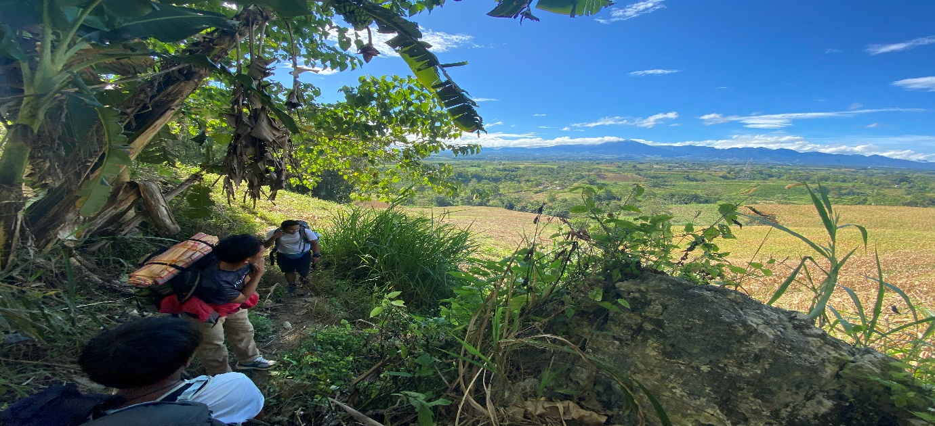Climb starting point: This is our starting point of the climb.

Trails:

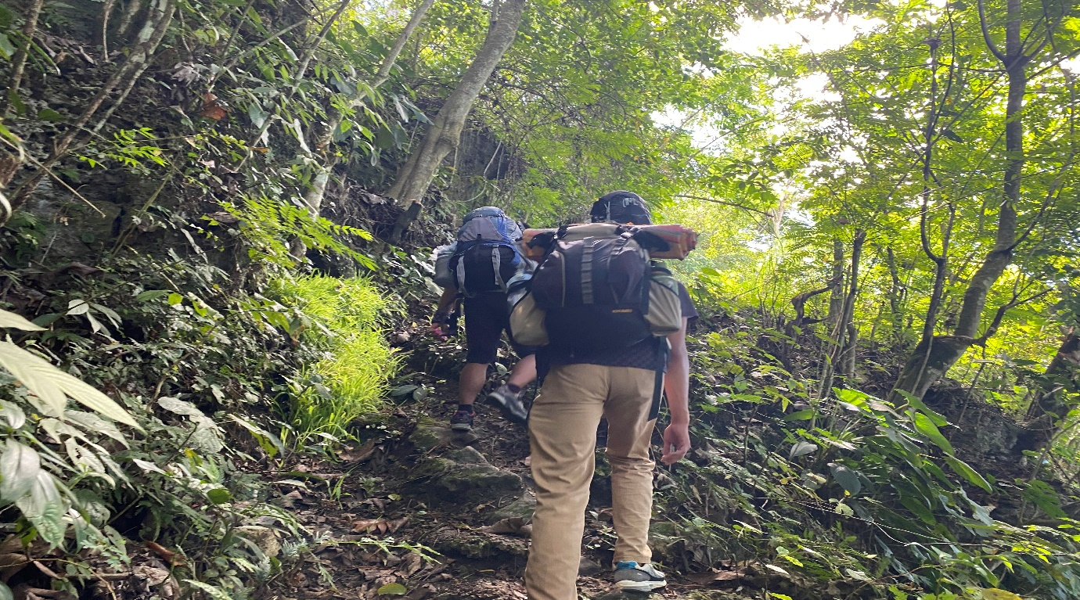

Water Sources:

Water source #1

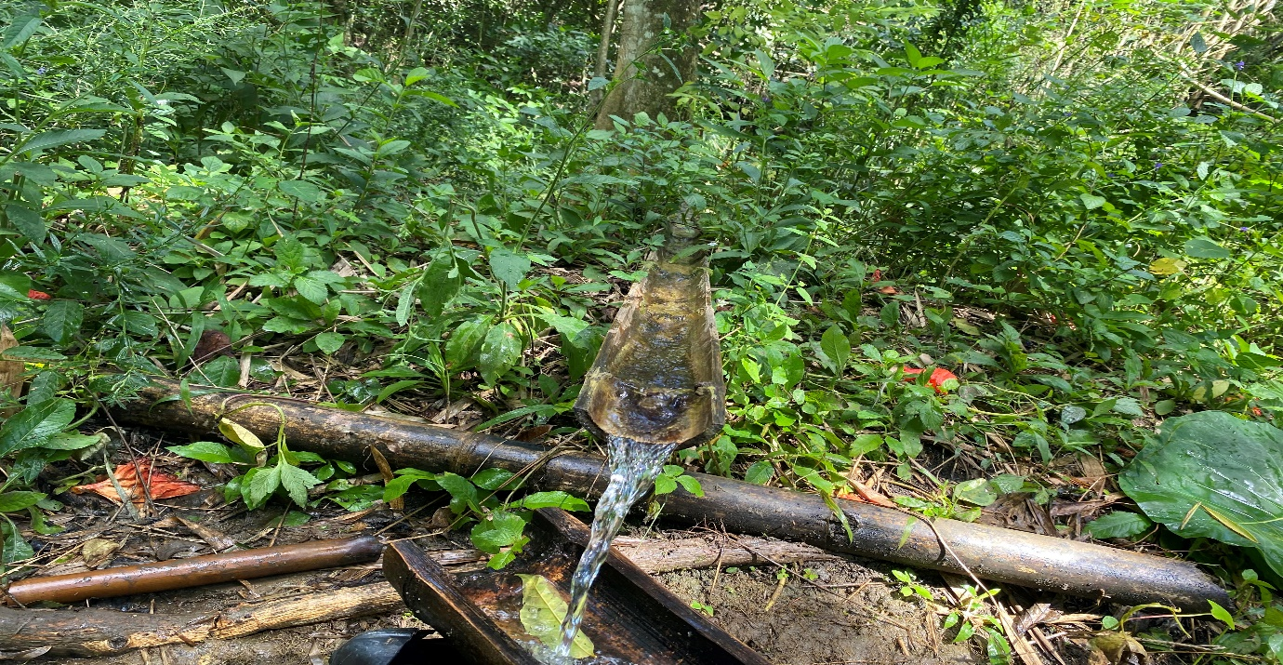

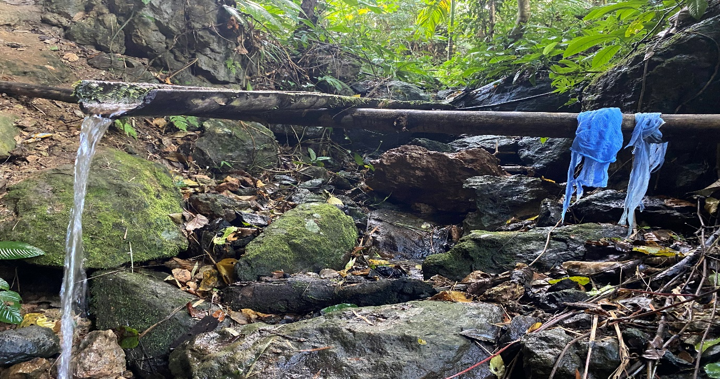Water source #2

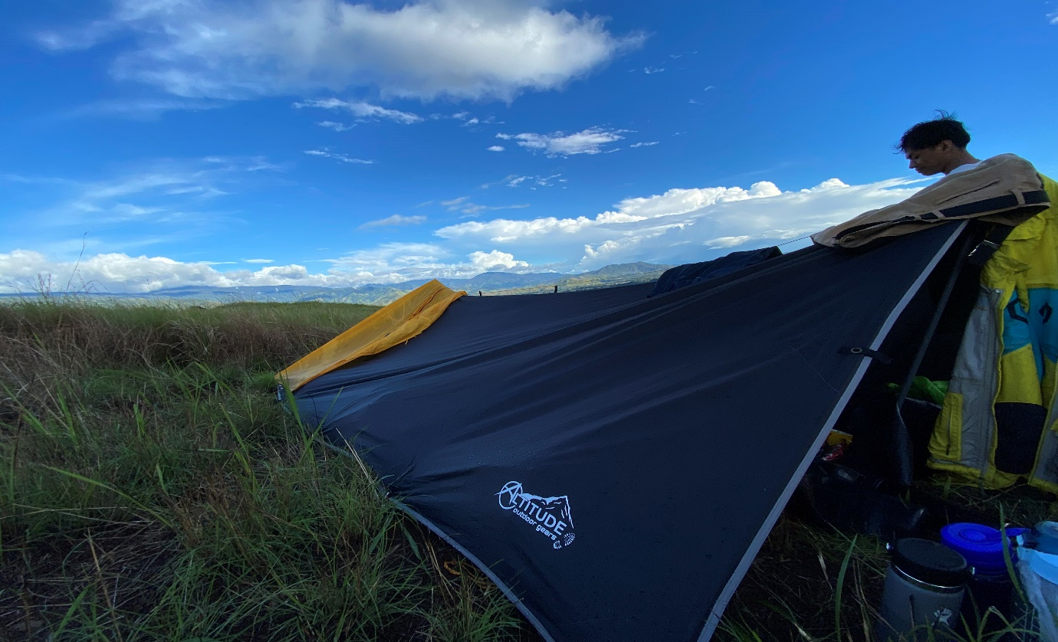Mt.Palaopao’s Peak Picture:

***Implementation of*** ***Leaflet Map, Dynamic Cards, Dynamic elements and Modal.***

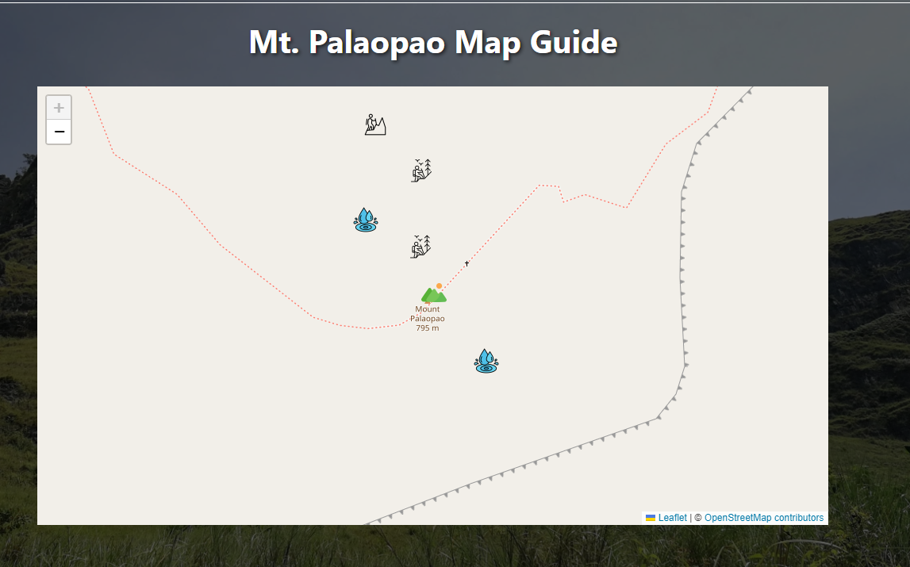***Leaflet Map:*** We used this to display the map of Mt.Palaopao to put markings on the water sources and the trails.

***Dynamic Cards:*** We used dynamic cards to make the image clean and precise.

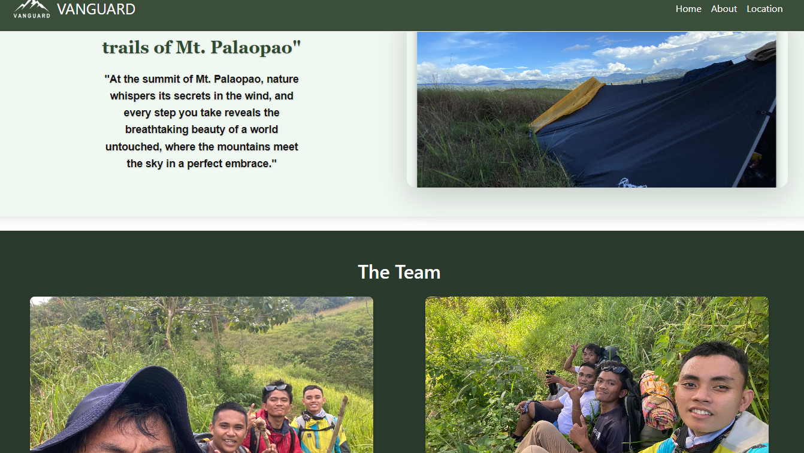

***Dynamics Elements and Modal:*** We used basic events along with modal and dynamic elements to search for water sources.

